Chapter 11, Solution 72.
(a) 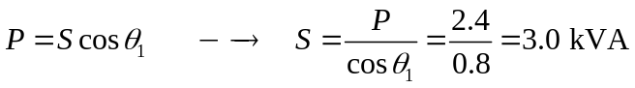
Hence, S = 2.4 + j1.8 kVA
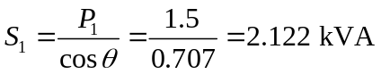
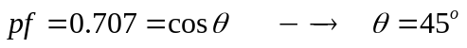
Since,
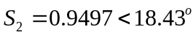
pf = cos 18.43º = 0.9487

(b)
